**ST. XAVIER’S COLLEGE**

**(Affiliated to Tribhuvan University)**

Maitighar, Kathmandu



**Computer Graphics**

**LAB Assignment #7**

**Submitted by:**

Lokendra Puri  
013BSCCSIT023

**Submitted to:**

|  |  |
| --- | --- |
| Er. Anil Sah  Lecturer, St. Xavier’s College |  |

Date of Submission: 1st September, 2015

STATEMENT:WAP TO IMPLEMENT VARIOUS TRANSFORMATIONS.

SOURCE CODE:

//---------------------------------------------------------------------------

#include <vcl\vcl.h>

#pragma hdrstop

#include "Unit1.h"

#include<math.h>

//---------------------------------------------------------------------------

#pragma resource "*.dfm"

TForm1 *Form1;

int TX,TY,i,j,a,b,x,y;

//---------------------------------------------------------------------------

__fastcall TForm1::TForm1(TComponent* Owner)

: TForm(Owner)

{

}

//---------------------------------------------------------------------------

void __fastcall TForm1::TRANSLATIONClick(TObject *Sender)

{

TX=StrToInt(Edit1->Text);

TY=StrToInt(Edit2->Text);

x=Image1->Height;

y=Image1->Width;

for (i=0;i<=x;i++)

{

for (j=0;j<=y;j++)

{

a = i+TX;

b = j+TY;

Image2->Canvas->Pixels[a][b]=Image1->Canvas->Pixels[i][j];

}

}

}

//---------------------------------------------------------------------------

void __fastcall TForm1::SCALINGClick(TObject *Sender)

{

TX=StrToInt(Edit3->Text);

TY=StrToInt(Edit4->Text);

x=Image1->Height;

y=Image1->Width;

for (i=0;i<=x;i++)

{

for (j=0;j<=y;j++)

{

a = i*TX;

b = j*TY;

Image3->Canvas->Pixels[a][b]=Image1->Canvas->Pixels[i][j];

}

}

}

//---------------------------------------------------------------------------

void __fastcall TForm1::ROTATIONClick(TObject *Sender)

{

int x,y,rot,a,b,i,j;

x=Image1->Height;

y=Image1->Width;

rot=StrToInt(Edit5->Text);

for(i=0;i<=x;i++)

{

for(j=0;j<=y;j++)

{

a=i*cos(rot)-j*sin(rot);

b=j*cos(rot)+i*sin(rot);

Image4->Canvas->Pixels[a][b]=Image1->Canvas->Pixels[i][j];

}

}

}

//-----------------------------------------------

INPUT SCREEN:

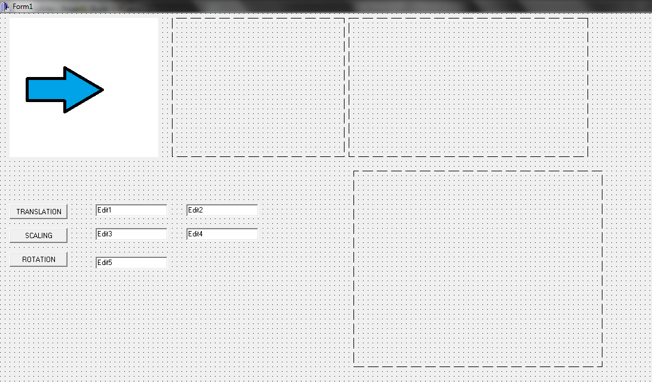

OUTPUT:

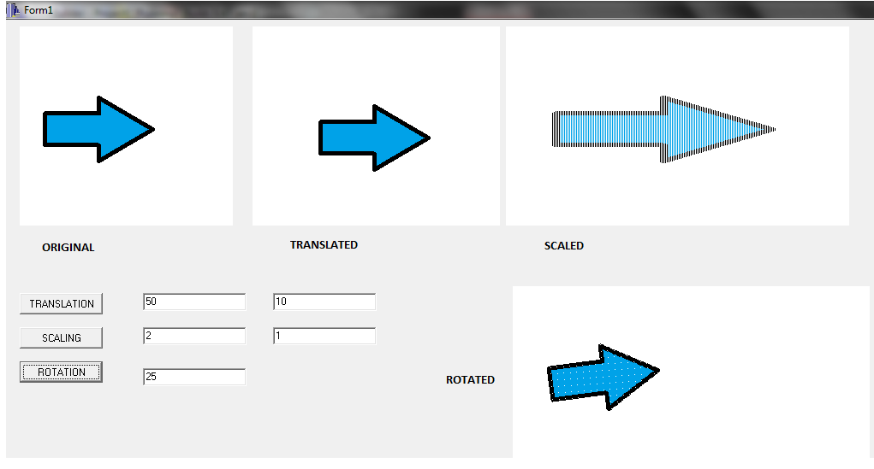

CONCLUSION:

Hence, transformations such as translation, scaling and rotation were implemented using c++ builder.